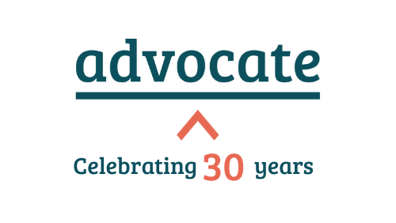

Bar Pro Bono Awards 2026
Kindly sponsored by LexisNexis

Introduction
Each year Advocate facilitates the Bar Pro Bono Awards for chambers, barristers and chambers’ staff who are recognised for their outstanding commitment to pro bono work.

Rules of Entry
- All nominations must include this completed form and a maximum of two supporting letters/documents. Each supporting document should be no more than 500 words. This is a strict word limit.
- Nominations should be submitted in one award category only.
- Self-nominations are accepted (with a maximum of two supporting letters/documents as above).
- The judges’ decision is binding and final.
- The deadline for nominations is Friday 30th January 2026 and the nomination form can be found below.

What happens after the closing date?
- Our panel of judges will consider the applications.
- All shortlisted finalists will be published in the awards brochure, in social media, and on Advocate’s website.
- Shortlisted nominees will be invited to the Awards ceremony taking place on 19th May 2026.

Award categories and judging criteria:

1  2  3  4 | Young Pro Bono Barrister of the Year (under 7 years’ call)  Junior Pro Bono Barrister of the Year  Pro Bono KC of the Year  International Pro Bono Barrister of the Year
The judges will consider
- The pro bono work undertaken in the last 12 months.
- The impact of the pro bono work on individuals or communities.

5 | Lifetime Achievement in Pro Bono, the Sydney Elland Goldsmith Award
The judges will consider
- The long-term contribution to pro bono made over the nominee’s career in addition to their work on specific pro bono cases. As 2026 celebrates our 30th anniversary, we are keen to recognise barristers who have made an impact over the last 30 years.
- The impact of the pro bono work on individuals or communities.
6 | Pro Bono Chambers’ Professional of the Year
This category is open to all chambers’ staff including practice managers, clerks, those involved in business development, and those managing chambers. The judges will consider

- The work undertaken by the nominee to champion pro bono in chambers in the last 12 months.
- The impact of this work on chambers’ commitment to, and delivery of, pro bono work.

7 | Pro Bono Chambers of the Year
The judges will consider
- The work undertaken to champion, and increase the delivery of, pro bono work in chambers in the last 12 months.
- The impact of chambers’ pro bono work on individuals or communities.

8 | Pro Bono and Social Responsibility Initiative of the Year
This category recognises pro bono initiatives and social responsibility initiatives, so please submit applications under either heading.

Nominations must provide evidence that programmes or initiatives have a clearly defined purpose and can demonstrate positive impact.
- Pro bono initiatives will be recognised for their commitment to deliver pro bono services for a specific project with barristers.
- Social responsibility initiatives will recognise projects led by individuals, chambers or cross-Bar collaboration. For example:
- Community and/or charitable projects (fundraising, working in schools, projects in the local community, public legal education etc)
- Diversity and social mobility (access, retention and progression programmes)
- Supply chains (e.g., innovative ways of auditing supply chains).
9 | John Collins Pro Bono Excellence Award
 | Not applicable. Nominations for this award only come from Advocate’s casework team.

Bar Pro Bono Awards 2026 - Nomination Form
- Details of nominee

Full Name and Honours

Chambers / Workplace

Year of call

Circuit / Region

Contact Telephone Number

Email Address:

- Your Details
Your Name

Relation to Nominee

Contact Telephone Number

Email Address

Date of Nomination

- Award Category nominated for

- In no more than 250 words, please summarise why you feel the nominee deserves to win this category, demonstrating how the nomination meets the judging criteria set out above.

[insert below]

- Supporting letters
Please enclose two supporting letters, of no more than 500 words in length each.

500 words is a strict word limit – nominees are welcome to highlight or extract the most relevant sections of longer documents, but please observe this word limit. Documents that are longer than 500 words will not be considered.

Suggested documents include letters of thanks, recommendations from your Head of Chambers, solicitors or colleagues who have worked on the case with the individual, or pro bono clients themselves. The supporting letters should show insight into the pro bono work of the nominee.

Please note: If more than two supporting letters are sent, we will only accept the first two attachments sent in your nomination.

- Final submission confirmation (please circle)

Are you happy for Advocate to use information provided in your nomination in external communications around the awards, such as the nominees brochure and social media? (See the previous year’s nominees brochure here). | Yes/No

Please return this completed form and supporting letters by email to awards@weareadvocate.org.uk

